File chooser in java fx:

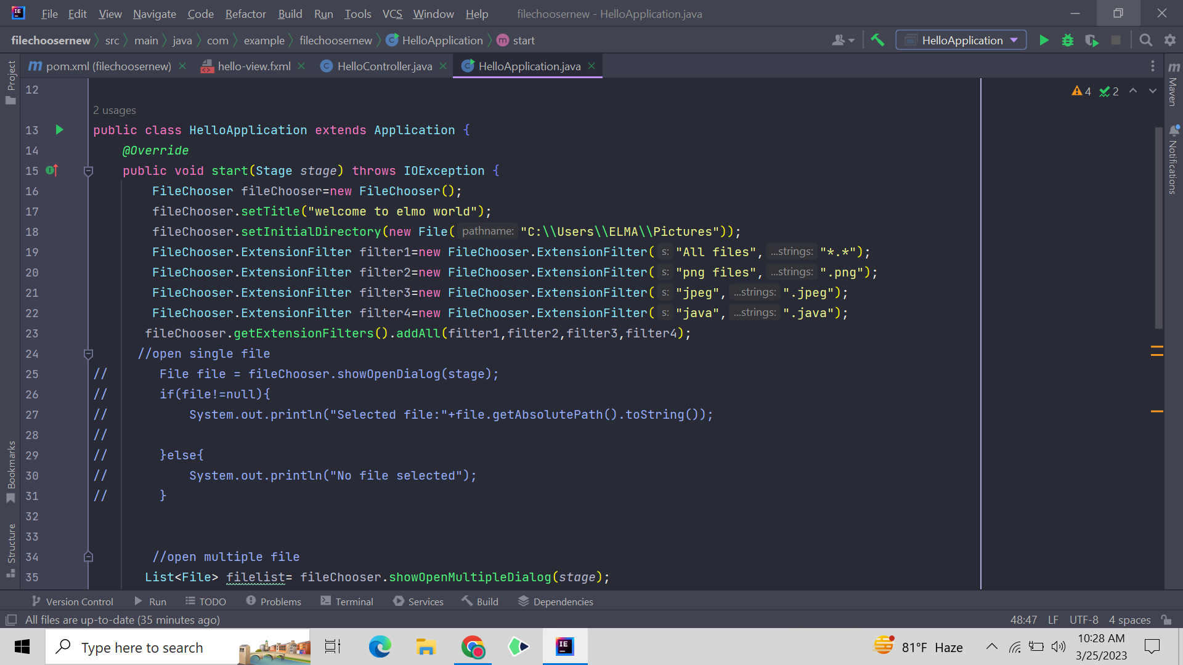

Opening multiple file and lastly showing the option of saving file:

